Cogging Torque Reduction in a 40-Pole/24-Slot Permanent Magnet Generator Using Magnet Edge Shaping and Slot Opening Adjustment

Irwan Firdaus¹, Dhami Johar Damiri^{2*}, Tajuddin Nur³
Institut Teknologi PLN, Indonesia^{1, 2}
Universitas Katolik Indonesia Atma Jaya, Indonesia³
Email: dhami@itpln.ac.id*

 |  | Abstract
Keywords:  cogging torque; PMG; magnet edge shaping; slot opening; FEMM 4.2 |  | Indonesia’s relatively low average wind speed (3–6 m/s) necessitates low-speed wind turbines using multipole permanent magnet generators (PMGs); however, the 40-pole/24-slot configuration tends to produce high cogging torque. This elevated cogging torque can negatively affect starting performance, induce vibration, and reduce overall efficiency. This study reduces the cogging torque of a 40-pole/24-slot PMG through magnet edge shaping and stator slot-opening adjustment. A 2D magnetostatic finite element analysis (FEA) was performed using FEMM 4.2 for three designs: a baseline model (2.0 mm slot opening), an edge-shaped model, and a combined edge-shaped model with a 1.8 mm slot opening. The maximum cogging torque decreased from 0.016676 N·m to 0.000395 N·m and 0.000141 N·m, corresponding to reductions of 97.63% and 99.15%, respectively. Flux density maps confirm a more uniform air-gap flux distribution in the combined design without altering the machine’s main dimensions. The combination of magnet edge shaping and slot-opening reduction is highly effective in minimizing cogging torque without changing the generator’s primary dimensions. This method is practical and suitable for improving the performance of small-scale PMGs in low-speed wind turbine applications.

INTRODUCTION
The ever-increasing demand for electrical energy is driving the use of renewable energy sources (Afril & Batih, 2024; Ariansyah Putra & Prabowo, 2025; Sitompul & Damiri, 2023), including wind power, especially in remote areas not yet connected to the main electricity grid (Johar Damiri, 2025; Johar Damiri & Nevella Sembiring, 2023; Prasetyo & Arifin, 2025). Unlike countries with subtropical climates, many locations in Indonesia experience average wind speeds of only around 3–6 m/s, as reported in the Indonesian Energy Outlook and studies of national wind energy potential (National Energy Council, 2023). Experimental studies on four-blade Darrieus wind turbines have shown that within this wind speed range, sufficient power can still be generated to serve household and small commercial loads if the rotor geometry and operating conditions are optimized (Kamal et al., 2021). This situation necessitates the development of wind turbines and generators specifically designed for low-speed operation.
For low wind speeds, a direct-drive turbine configuration combined with a multipole permanent magnet generator (PMG) is an attractive option because it can produce torque and voltage at low rotational speeds, offers high efficiency, and is suitable for small-scale wind turbine systems in Indonesia (Abduh et al., 2025). However, PMGs with fractional-slot configurations, such as 40 poles/24 slots, tend to produce significant cogging torque due to the interaction between the rotor’s permanent magnet flux and the stator teeth and slots, even when the stator current is zero. Cogging torque is periodic with respect to rotor position and can inhibit self-starting, cause vibration and noise, and degrade torque quality, especially in low-speed wind turbines that are sensitive to starting torque (Hao et al., 2023; Islam et al., 2009). Comparative studies between integral-slot and fractional-slot machines show that fractional-slot structures can provide higher cogging torque frequencies with lower amplitudes but are highly sensitive to variations in air-gap reluctance in front of the stator teeth (Nur et al., 2023; Said et al., 2024).
Various techniques have been proposed to reduce cogging torque, including fractional-slot arrangements, pole-to-slot ratio adjustment, stator or rotor skewing, magnet edge shaping, dummy slot and tooth modification, and stator slot opening width adjustment (Hao et al., 2023; Ocak & Aydin, 2020). On the stator side, dummy slot implementation and slot opening adjustment have been reported to reduce cogging torque while improving vibration and noise characteristics (Nur et al., 2020; Zhao et al., 2017). On the rotor side, magnet edge trimming, pole shoe height adjustment, and magnet shape optimization have been shown to alter the air-gap flux distribution and significantly reduce peak cogging torque (Ling & Nur, 2016; Nur & Herlina, 2018, 2019; Nur & Mawar, 2020). Magnet or rotor skewing techniques, including step-skewed rotors and double skew in axial flux machines, have also been reported to effectively reduce cogging torque and torque ripple while maintaining average torque (Luu et al., 2018; Mandasari et al., 2023; Ocak & Aydin, 2020; Sato et al., 2022).
Nur and colleagues’ research group have consistently studied PMGs and permanent magnet synchronous generators (PMSGs) using various combinations of magnet edge shaping techniques, slot opening configurations, and dummy slots in fractional-slot structures. Their studies show that cogging torque reductions of up to 98–99% can be achieved using finite element method (FEM) simulations with FEMM 4.2 (Abduh et al., 2025; Nur et al., 2021; Nur & Herlina, 2018, 2019; Nur & Mawar, 2020; Said et al., 2024). Other approaches, such as the two-step notching technique at the tip of the rotor magnet, demonstrate that modifying magnet geometry can simultaneously reduce cogging torque by up to approximately 99.7% and minimize vertical and horizontal shaft displacement, thereby suppressing tangential and radial magnetic forces that induce mechanical vibrations (Correia et al., 2024). However, specific studies on multipole PMGs with a 40 rotor pole/24 stator slot (40/24) configuration remain limited, even though this configuration is highly relevant for low-speed wind turbine applications in Indonesia (Abduh et al., 2025; Correia et al., 2024; Nur & Mawar, 2020; Said et al., 2024).
Based on this research gap, this study focuses on reducing the cogging torque of a 40/24 PMG for low-speed wind power generation at wind speeds of 3–6 m/s. The approach involves a combination of modifying the rotor magnet tip profile (magnet edge shaping) and reducing the stator slot opening width from 2.0 mm to 1.8 mm, using FEMM 4.2-based electromagnetic analysis and torque calculation via the Maxwell stress tensor method (Meeker, 2020). The main contribution of this study is the presentation of cogging torque characteristics and magnetic flux distribution for the baseline design, the magnet edge shaping design, and the combined design incorporating magnet edge shaping with a 1.8 mm slot opening in a 40/24 PMG. The results show that cogging torque can be reduced by up to 99% without altering the machine’s main dimensions, making this approach highly relevant for the design of small-scale PMGs in low-speed wind turbine systems in Indonesia (Said et al. 2024).
The objective of this study is to analyze the effect of magnet edge shaping and slot opening adjustment on cogging torque reduction in a 40-pole/24-slot permanent magnet generator and to identify the most effective design modification for low-speed wind turbine applications. In addition, this study aims to compare the electromagnetic performance of the baseline design, the magnet edge shaping design, and the combined modification design in terms of cogging torque magnitude and magnetic flux distribution. The benefits of this study are both theoretical and practical. Theoretically, this research is expected to enrich the literature on cogging torque reduction techniques in fractional-slot permanent magnet generators, particularly for 40/24 configurations that remain underexplored. Practically, the results are expected to provide a simple and feasible design reference for developing small-scale PMGs for low-speed wind turbine systems in Indonesia, since the proposed method does not require changes to the machine’s main dimensions and can therefore be more easily implemented in manufacturing.

METHOD
Basic PMG Design
The research object is a three-phase PMG with a 40-pole rotor and 24-slot stator configuration (40/24), which is included in the fractional-slot category with a value of
$q=\frac{S}{3P}= \frac{24}{3 x 40}=0,2$ (1)
Fractional-slot configuration with small q value is known to reduce the amplitude of cogging torque, but at the same time it is very sensitive to variations in the air gap reluctance around the stator teeth (Ling & Nur, 2016; Nur et al., 2023; Said et al., 2024).

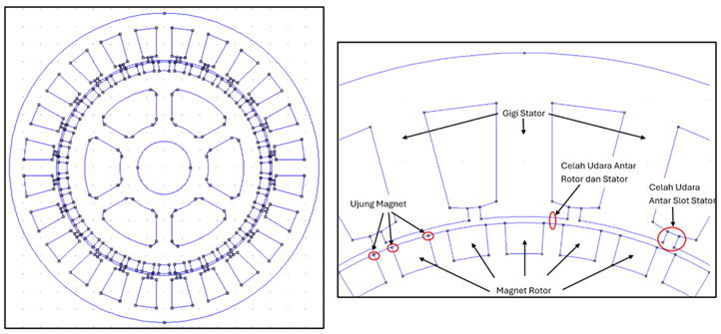
Figure 1. Left: PMG geometry, right: PMG geometry details
Source: Developed by the author (2025)

Figure 1 shows the PMG geometry in FEMM 4.2 modeling. The rotor diameter is 120 mm and uses surface magnets that follow the rotor curvature with a 30° mechanical angle between the magnetic poles. The stator outer diameter is 175.2 mm, the stator tooth height is 26.6 mm, the stator slot height is 2 mm, the stator slot spacing is 2 mm, and the rotor and stator air gap is 1 mm.
The stator teeth act as the main flux path from the rotor magnets through the air gap and then to the stator. The rotor magnets generate the main flux that traverses the air gap. The magnet edge is the part of the magnet closest to the stator teeth and is the primary source of tangential magnetic force that causes cogging torque. The rotor–stator air gap determines the global reluctance of the machine, while the air gap between the stator slots (slot opening) determines the local reluctance variation in front of the stator teeth (Ling & Nur, 2016; Nur et al., 2021; Nur & Mawar, 2020; Said et al., 2024).

Cogging Torque in Permanent Magnet Generators
In permanent magnet machines, cogging torque arises due to the interaction between the rotor's permanent magnetic flux and changes in the air gap reluctance caused by the presence of stator teeth and slots. When the rotor rotates, the distribution of the air gap reluctance changes periodically with the rotor angle θ, so that the magnetic energy in the air gap also changes and creates a torque that tends to "hold" or "pull" the rotor to a certain position (Hao et al., 2023; Islam et al., 2009).
In terms of energy, the cogging torque can be expressed as the derivative of the magnetic energy in the air gap W_m with respect to the rotor angle:
$Tcog \left(θ\right)= -\frac{∂W_{m} (θ)}{∂θ}$ (2)
With $W_{m}$ obtained from the integration of the magnetic energy density in the air gap:
$Wm=\int_{V}{\frac{B^{2}}{{2μ}_{0}}} dV$ (3)
Where $B$ is the magnitude of the magnetic flux density in the air gap, $μ_{0}$ is the permeability of a vacuum, and $V$ is the volume of the air gap (Hao et al., 2023; Meeker, 2020). This formulation asserts that any change in the distribution $B$ on the rotor angle will directly impact the cogging torque.
In a 40/24 permanent magnet generator (PMG), the cogging torque can also be expressed in terms of the relationship between the air gap flux $Φ_{g}$ and air gap reluctance $R_{g}$. assuming the main flux passes through the gap predominantly, the change in magnetic energy in the air gap results in:
$Tcog= -\frac{1}{2} Φ_{g}^{2} \frac{dR_{g}}{dθ}$ (4)
The air gap reluctance depends on the average distance between the magnet surface and the stator teeth, so it can be written:
$R_{g}= \frac{l_{g}}{μ_{0}A_{g}}$ (5)
With $l_{g}$ is the effective air gap length, $A_{g}$is the cross−sectional area of ​​the air gap, and $μ_{0}$ permeability of a vacuum. Equations (4)–(5) show that when geometry causes a change $l_{g}$ or $A_{g}$ to the rotor angle—for example, because the stator tooth contour and magnet tip are not uniform—then $R_{g}(θ)$ becomes periodic and the cogging torque increases (Nur et al., 2021; Nur & Herlina, 2018).
In addition to the energy and reluctance approaches, the cogging torque can be directly related to the magnetic forces acting in the air gap. The two main force components in the air gap are the normal magnetic force and the tangential magnetic force, both of which originate from the normal flux density component.$B_{n}$ and tangential $B_{t}$. Based on the Maxwell stress formulation, the tangential force per unit area (tangential stress) can be written as (Nur et al., 2021):
$F_{t}= \frac{1}{μ_{0}} B_{n}B_{t} cos θ$ (6)
while the normal force per unit area is:
$F_{n}= \frac{1}{{2μ}_{0}} \left(B_{n}^{2}- B_{t}^{2}\right) sinθ$ (7)
This tangential force is the dominant contributor to the cogging torque, as its direction is parallel to/opposite to the rotor rotation. The normal force component contributes more to the unbalanced magnetic pull and shaft displacement, rather than directly to the cogging torque (CORREIA et al., 2024; Ling & Nur, 2016; Nur & Mawar, 2020).
By integrating the tangential force along the air gap path, the cogging torque can be written as:
$T_{cog}= L_{stk} \int_{0}^{2π}{F_{t}} \left(θ, ϕ\right)r^{2} dϕ$ (8)
Where $L_{\text{stk}}$ is the length of the machine stack (axial direction), $r$ is the radius of the integration path in the air gap, and $ϕ$ is the position angle on the trajectory. By substituting Equation (6) into Equation (8), we obtain:
$T_{cog}= \frac{L_{stk}}{μ_{0}} \int_{0}^{2π}{r^{2} B_{n}}\left(θ, ϕ\right) B_{t}\left(θ, ϕ\right) dϕ$ (9)
Equation (9) states that the cogging torque is greatly influenced by the product of the normal and tangential flux components in the air gap. The larger $B_{t}$ in the area of ​​the tip of the magnet that is directly opposite the stator slot door, the bigger it is $F_{t}$ and $T_{\text{cog}}$ (Nur dkk., 2021; Nur & Mawar, 2020).
PMG 40/24 in this study, Equations (4)–(9) basically show that the cogging torque is very sensitive to two main things: the air gap reluctance and the distribution of the flux components around the magnet tip. Adjusting the reluctance in front of the stator teeth, for example by changing the width of the gap between the slots (slot opening), will change the profile. $R_{g}(θ)$ as well as distribution $B_{n}$, so that it directly affects the size $T_{\text{cog}}$. On the other hand, magnet edge shaping, which lowers the height of the magnet at the edge, effectively increases the local distance between the magnet and the stator teeth, reducing the component $B_{t}$ in the area, and ultimately reduce the tangential force $F_{t}$ and its contribution to cogging torque. These two principles form the basis for the new PMG 40/24 design in this study, namely a combination of magnetic edge shaping and a reduction in slot opening from 2.0 mm to 1.8 mm.

Cogging Torque Reduction Technique and Modification Design
Cogging torque reduction techniques in permanent magnet machines can generally be grouped into three approaches, namely stator modification, rotor magnet modification, and a combination of both as shown in Figure 2. Various reviews show that these strategies are basically directed at smoothing changes in air gap reluctance and reducing variations in magnetic energy with rotor angle, so that the cogging torque amplitude can be suppressed without sacrificing average torque performance (Hao et al., 2023; Pranjić & Virtič, 2024).
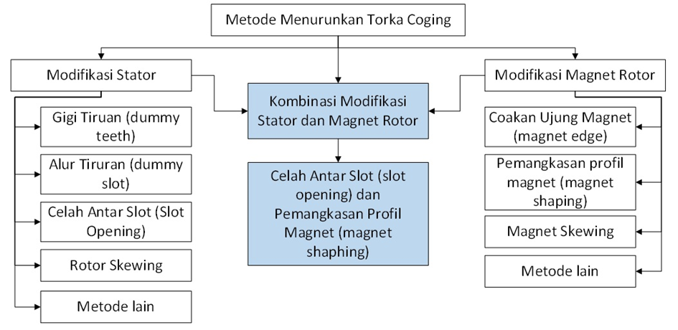
Figure 2. Method for reducing cogging torque
Source: Adapted from relevant literature and processed by the author (2025)

In stator modification, techniques frequently used include the addition of dummy teeth, dummy slots, adjusting the slot opening width, and varying the stator tooth shape. The application of dummy slots to the stator has been reported to reduce cogging torque while affecting vibration and noise characteristics, where the selection of the dummy slot position and geometry is a key factor (Nur et al., 2020; Zhao et al., 2017). Other studies on integral and fractional slot generators confirmed that the combination of slot opening settings and dummy slot patterns provides a significant reduction in cogging torque while maintaining the average torque capability (Pranjić & Virtič, 2024; Said et al., 2024).
In rotor magnet modification, several key techniques include magnet edge shaping, magnet surface shape adjustment, and the introduction of axial channels in the rotor core. Geometry engineering of the magnet tip can alter the flux distribution in the air gap and reduce the peak cogging torque, while reducing the flux concentration at the stator tooth tips (Handini et al., 2018). Magnet or rotor skewing techniques, including step-skew and double-skew variations, have also been reported to be effective in reducing cogging torque and torque harmonics while maintaining the average torque at an acceptable level (Luu et al., 2018; Mandasari et al., 2023; Nur et al., 2021; Ocak & Aydin, 2020; Sato et al., 2022).
This study uses a combination approach of rotor and stator modifications, namely in the box "Gap Between Slots and Magnet Profile Trimming (magnet edge shaping)" in Figure 2. The modifications carried out focus on adjusting the gap between stator slots by reducing the slot opening from 2.0 mm to 1.8 mm and trimming the rotor magnet tip profile (magnet edge shaping) in the PMG 40/24 configuration as shown in Figure 3. The reduction in slot opening is aimed at leveling the reluctance variation of the air gap in front of the stator teeth and reducing the gradient $dR_{g}/dθ$, while trimming the tip of the magnet is intended to reduce the tangential flux density component $B_{t}$ in the slot door area. These two techniques were chosen because the literature confirms that slot opening and magnetic structure are two parameters that significantly influence the cogging torque in fractional slot number machines and can be analyzed effectively using FEMM 4.2 (Nur & Mawar, 2020; Said et al., 2024).
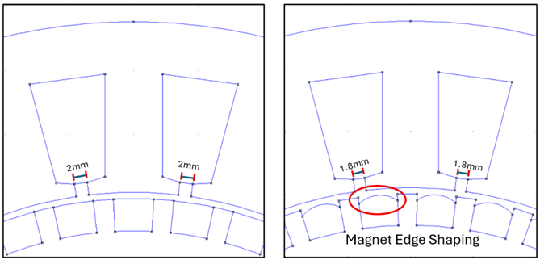
Figure 3. Left: Basic PMG Design, Right: Combination of Design Modifications

Source: Developed by the author (2025)

Research Flow Chart
The complete stages of this research are summarized in the flowchart in Figure 4. The research began with a literature review of the cogging torque characteristics of permanent magnet machines and various reduction techniques, particularly for fractional slot number configurations. The information from this stage served as the basis for developing the initial design of the PMG 40/24, along with the determination of geometric parameters and material types, as described in section 2.1.
After the initial design was established, modeling and simulation of the basic design were performed using FEMM 4.2 to obtain the initial cogging torque values ​​and the magnetic flux distribution in the air gap. This basic design served as a reference for comparison when the design was modified. The next stage involved applying cogging torque reduction techniques through magnet profile modifications (magnet edge shaping) and stator slot opening adjustments, as described in section 2.3.
Each design variant resulting from the combination of magnet profile and slot opening changes was then further analyzed using FEMM 4.2 numerical simulations to calculate the cogging torque and examine the magnetic flux distribution (section 2.5). The maximum cogging torque value of each design is compared with the base design using the cogging torque reduction indicator 𝐶(%) as explained in section 2.6. This modification and evaluation process is carried out iteratively until the PMG 40/24 configuration is obtained with a cogging torque reduction above the specified target (more than 98% of the base design).
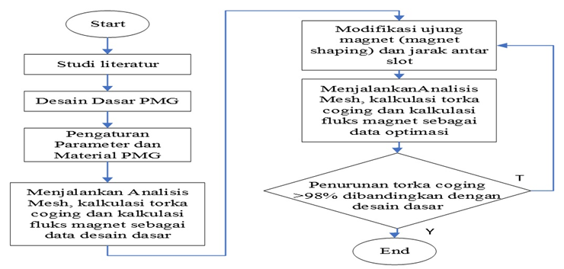
Figure 4. Research Flowchart

Source: Developed by the author (2025)

Numerical Analysis Using FEMM 4.2
The numerical analysis in this study was performed using Finite Element Method Magnetics (FEMM) 4.2 software in 2D magnetostatic mode. FEMM was chosen because it can model the geometry of permanent magnet machines in detail, accommodate the nonlinear characteristics of ferromagnetic materials through B–H curves, and provide a Maxwell stress tensor-based torque calculation facility that aligns with the theoretical formulation of cogging torque in section 2.2 (Hao et al., 2023; Islam et al., 2009; Meeker, 2020).
The PMG 40/24 geometry is modeled as a 2D cross-section that includes the rotor, permanent magnets, stator teeth, stator, air gap, and stator interslot gaps. The differences between the design variants only lie in the magnet tip profile (surface magnets that follow the rotor curvature or magnet edge shaping) and the slot opening value (2.0 mm or 1.8 mm), while the other main dimensions are maintained so that the effect of modification on the cogging torque can be observed in isolation (Abduh et al., 2025; Nur & Mawar, 2020).
The rotor and stator core materials are defined as M-19 steel, while the permanent magnets are modeled as NdFeB. The air gap is filled with an air material with a permeability of $μ_{0}$. The outer boundary of the analysis domain is given a magnetic boundary condition in the form of a zero vector potential (Dirichlet boundary) or an equivalent mixed boundary condition, so that the magnetic flux is confined within the analysis area without disturbing the field symmetry (Meeker, 2020).
Once the geometry and material are defined, the working domain is discretized into triangular elements (meshing). The mesh is made denser in the air gap, around the magnet tips, and stator slot doors because the field gradient in these regions is sharp and greatly affects the cogging torque, while in the stator and rotor parts the mesh is made coarser. The FEMM then solves the magnetostatic equations for each rotor position by considering the nonlinearity of the material's B–H curve, so that the magnetic flux density distribution B over the entire domain is obtained for each rotor angle $θ$.
The cogging torque calculation is performed under open-circuit conditions. The rotor is rotated every 1° mechanically using a Lua script, and for each rotor position θ the magnetic field is solved. The electromagnetic torque is calculated by FEMM using the Maxwell stress tensor method on the path in the air gap, which is generally expressed as a function of the normal and tangential flux density components, B_n and B_t, as described in Equation (9) in section 2.2 (Meeker, 2020; Nur & Mawar, 2020). Since the phase current is zero, the obtained torque curve T(θ) is considered as the cogging torque curve.
In addition to the torque values, FEMM also provides magnetic flux density contour maps that are used to evaluate the flux distribution patterns in the stator teeth, stator, and air gap. Visual analysis of these contour maps allows the identification of areas with high flux concentrations, as well as helps explain the physical mechanism of the reduction in cogging torque due to the combination of magnetic edge shaping and the reduction of the slot opening to 1.8 mm as shown in Figure 3. Thus, the numerical analysis using FEMM 4.2 not only provides quantitative values ​​of cogging torque for each design variant, but also an electromagnetic basis for assessing the quality of the proposed modified design.

Calculation of Cogging Torque Drop
In this study, FEMM 4.2 is used to calculate the cogging torque in the 2D magnetostatic domain by gradually rotating the rotor relative to the stator. The rotor is shifted numerically every 1° mechanically until all the magnetic poles pass through the same tooth/slot position, thus obtaining a series of cogging torque values. $T_{\text{cog}}(θ)$ for one complete cycle of magnet–tooth interaction. This discrete angular displacement approach is commonly used in FEA-based cogging torque analysis of permanent magnet machines (Hao et al., 2023; Islam et al., 2009; Nur & Mawar, 2020).
From a series of values $T_{\text{cog}}(θ)$ In each design, the next step is to determine the maximum and minimum torque values ​​in one cycle. The maximum positive and minimum negative torque values ​​are then used to calculate the absolute maximum cogging torque value, for example:
$CT=\max{(\left|T_{cog} (θ)\right|})$ (10)
Mark $CT$ this is then used as a representation of the magnitude of the cogging torque for each design. This procedure is consistent with the practice in cogging torque reduction studies using FEMM and other FEA software, where the cogging torque is evaluated from the maximum–minimum difference of the torque curve against the rotor angle (CORREIA et al., 2024; Nur & Mawar, 2020).
To assess the effectiveness of the modified design on the basic design, the percentage reduction in cogging torque is used, which is expressed as $CT(\%)$(cogging torque reduction). If $CT_{1}$ is the absolute maximum cogging torque value of the basic design and $CT_{2}$ is the absolute maximum cogging torque value for the modified design, then the percentage reduction is calculated by:
$CT\left(\%\right)=100\%- \frac{{CT}_{2}}{{CT}_{1}} x 100\%$ (11)
Mark $CT(\%)$ a positive result indicates that the modified design successfully reduced cogging torque compared to the base design. With this formulation, the research results can be directly compared with previous studies that reported the percentage reduction in cogging torque due to the application of magnetic edge shaping, dummy slots, or other combination techniques on fractional slot number machines (Abduh et al., 2025; CORREIA et al., 2024; Nur & Mawar, 2020).

RESULT AND DISCUSSION

Torque Cogging Characteristics of PMG 40/24 Basic Design
Initial simulations were performed on a basic PMG 40/24 design with square permanent magnets and a 2.0 mm slot opening. The rotor was rotated numerically every 10 seconds. 1° mechanically until all the magnetic poles pass through the same tooth/slot position, so that a cogging torque series is obtained 𝑇cog(𝜃) for one complete cycle. From the series, the maximum and minimum values ​​are taken, then the absolute maximum value is calculated. 𝐶𝑇1 as explained in section 2.6.
The baseline design achieved a maximum cogging torque of 0.016676 N m with a sharp, repeating waveform, as shown in Figure 8. This indicates a strong interaction between the rotor's permanent magnetic flux and variations in the air gap reluctance in front of the stator teeth in the 40/24 fractional slot configuration, potentially causing vibration, noise, and initial resistance in low-speed wind turbines.
The magnetic flux density distribution of the baseline design is shown in Figure 5. The high flux concentration at the stator tooth tips around the slot gates, with values ​​approaching 1.081–1.138 T, indicates a sharp field gradient and a large change in reluctance with rotor angle. This flux pattern aligns with the relatively high cogging torque and underlies the need for geometry modifications to reduce cogging torque in subsequent designs.

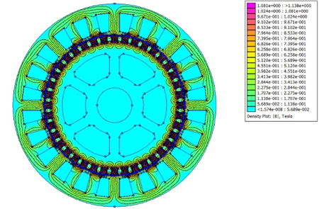
Figure 5. Basic Design Magnetic Flux Density
Source: FEMM 4.2 simulation results, processed by the author (2025)

The Effect of Magnet Edge Shaping (Convex Magnet)
The second design employs magnet edge shaping by shaping the rotor magnets into a convex profile, while the stator slot opening remains 2.0 mm. The magnet tips are trimmed so that the edges are lower than the center, without changing the main dimensions of the rotor or stator. Using the same simulation procedure (1° rotor shift and taking the absolute maximum value), a maximum cogging torque of 0.000395 N m is obtained, as shown in Figure 8. The percentage reduction in cogging torque is calculated using Equation (11) in Section 2.6 by comparing this value to the baseline design, resulting in a reduction of approximately 97.63%. This means that simply modifying the magnet tips reduces the cogging torque by almost two orders of magnitude.
The magnetic flux density distribution in the magnet edge shaping design is shown in Figure 6. Compared to the baseline design, the flux contour in the air gap appears smoother and more even, with a slightly reduced flux concentration at the stator tooth tips. Based on the color scale in Figure 6, the maximum flux density at the stator teeth remains within the range ±1,1 T, However, the high-flux-density area around the slot door is narrower than the base design. The convex magnet shape allows the magnetic field lines to enter the air gap more gradually, reducing the tangential flux component around the slot door. The decrease in field gradient in this area is consistent with the reduction in maximum cogging torque achieved in the second design.

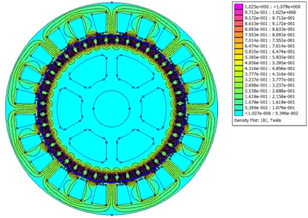
Figure 6. Magnetic Flux Density of Edge Shaping Magnet
Source: FEMM 4.2 simulation results, processed by the author (2025)

The Effect of Combination of Magnet Edge Shaping and Slot Opening 1.8 mm
The third design combines magnet edge shaping with a reduction in the stator slot opening from 2.0 mm to 1.8 mm. In this configuration, in addition to the tangential flux at the magnet tip being reduced by the convex magnet shape, the variation in the air gap reluctance in front of the stator teeth is also smoothed out by narrowing the gap between the slots. Using the same simulation procedure, the maximum cogging torque obtained for the combined design is 0.000141 N m as shown in Figure 8. Compared with the baseline design using Equation (11), the combination of the convex magnet and the 1.8 mm slot opening results in a reduction in the cogging torque of approximately 99.15%. This value is smaller than the cogging torque in the magnet edge shaping design alone, so the adjustment in the slot opening can be viewed as an additional contribution above the main effect of the magnet edge shaping, or as a fine-tuning step that smooths out the changes in air gap reluctance.
The magnetic flux density distribution for the combination design is shown in Figure 7. Compared to Figure 5 and Figure 6, the flux contour in the air gap appears most uniform with a smoother color transition around the stator slot door, without any excessive flux concentration at the tooth tips. Based on the color scale in Figure 7, the maximum flux density in the stator teeth is in the range of 1.06–1.12 T, still slightly below the maximum range of the basic design which reaches around 1.08–1.14 T and close to the flux distribution in the edge shaping magnet design which is in the range of 1.03–1.08 T. This indicates that the combination of the convex magnet and the 1.8 mm slot opening not only reduces the cogging torque, but also keeps the flux distribution below the saturation limit of the electrical steel while reducing the area with high flux density around the stator tooth tips. This more even flux pattern is consistent with the very small maximum cogging torque value of 0.000141 N·m, and confirms the effectiveness of the combination of both techniques in reducing the cogging torque in the PMG 40/24.

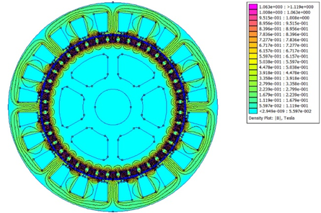
Figure 7. Edge Shaping Magnetic Flux Density and 1.8mm Slot Gap
Source: FEMM 4.2 simulation results, processed by the author (2025)

Discussion
To clarify the performance comparison of the three designs, all cogging torque simulation results are displayed in one graph as in Figure 8. The base design curve appears to dominate with a much larger cogging torque amplitude and forms a sharp triangular pattern that repeats at each rotor angle position. In the magnetic edge shaping curve with a 2.0 mm slot opening, the cogging torque amplitude drops drastically and moves close to the zero line so that the remaining torque ripple is relatively small. The magnetic edge shaping curve and the 1.8 mm slot opening are closest to the zero axis and are almost flat, indicating that the remaining cogging torque is very small.

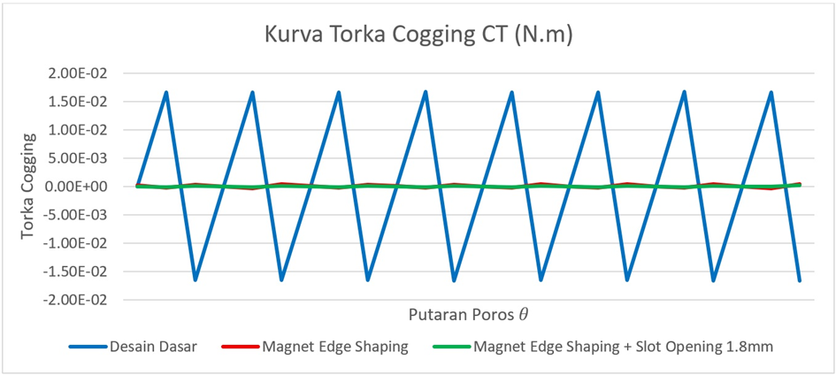
Figure 8. Cogging Torque Curve
Source: FEMM 4.2 simulation results, processed by the author (2025)

The visual pattern in Figure 8 is consistent with the maximum cogging torque values ​​obtained: 0.016676 N·m for the base design, 0.000395 N·m for the magnetic edge shaping and 0.000141 N·m for the combination design. If expressed in the form 𝐶(%) using Equation (11), magnetic edge shaping provides a reduction of approximately 97.63%, while the combination of magnetic edge shaping and a 1.8 mm slot opening increases the reduction to approximately 99.15% over the baseline design. This confirms that magnetic edge shaping is the main factor in reducing cogging torque in the PMG 40/24, while the reduction in slot opening acts as a further optimization that improves cogging torque reduction.
The electromagnetic picture behind these differences can be seen from the magnetic flux density distributions in Figures 5–7. In the basic design (Figure 5), the flux is highly concentrated at the stator tooth tips around the slot gates with densities approaching 1.1–1.14 T, forming a sharp field gradient and a large change in air gap reluctance with rotor angle. This condition results in a strong fluctuating tangential magnetic force and a high cogging torque. In the edge-shaping magnet design (Figure 6), the flux pattern in the air gap becomes smoother, the high flux density area at the tooth tips shrinks and the flux distribution along the circumference is more even, so that the tangential force fluctuations are reduced and the cogging torque drops to 0.000395 N m. The combination design (Figure 7) shows the most uniform flux distribution, with the maximum stator tooth density being around 1.06–1.12 T and a smaller saturated area, so that the local reluctance variation is further reduced and the maximum cogging torque remains 0.000141 N·m.
Overall, a comparison of Figures 5–7 and Figure 8 shows that magnet edge engineering first reduces the main tangential flux component that triggers cogging torque, while narrowing the slot opening to 1.8 mm serves to smooth out the changes in air gap reluctance as an additional fine tuning. This finding is in line with various studies that report that the combination of magnet modification and stator geometry provides the largest cogging torque reduction in fractional slot number machines while maintaining the main dimensions of the machine, making it relatively easy to implement at the manufacturing stage.

CONCLUSION
This study investigated cogging torque reduction in a 40/24 pole-slot permanent magnet generator (PMG) through geometric modifications, without altering the machine's main dimensions. The baseline design — using square magnets and a 2.0 mm slot opening — produced a maximum cogging torque of 0.016676 N·m, driven by high flux density concentrations at the stator tooth tips and sharp air gap reluctance variations, which risk disrupting self-starting and low-speed stability. Replacing the square magnets with convex-profiled magnets at the same slot opening reduced cogging torque by 97.63% to 0.000395 N·m by smoothing the air gap flux distribution; further narrowing the slot opening to 1.8 mm achieved an additional reduction to 0.000141 N·m — a 99.15% improvement over the baseline — yielding the most uniform flux distribution observed across all configurations. These gains were achieved solely through magnet tip geometry and slot opening adjustments, preserving pole count, slot count, air gap length, and magnet size, making the approach well-suited for small-scale PMG manufacturing and wind turbines operating in low wind speed regions of 3–6 m/s, such as those found across Indonesia. For future research, it is recommended to experimentally validate these simulation findings using a physical prototype, and to extend the optimisation study to include the combined effect of magnet skewing alongside convex shaping and slot opening reduction, which may further suppress residual torque ripple and improve overall generator performance under variable wind conditions.

REFERENCES
Abduh, S., Karunanithi, S., & Nur, T. (2025). Analysis of the cogging torque reduction in permanent magnet generators for a very low wind speed. Energies, 18(11). https://doi.org/10.3390/en18112802
Afril, Z., & Batih, H. (2024). Analisis risiko finansial dalam proyek photovoltaic (PV) rooftop segmen industri di Jawa Timur: Studi kasus di PT XXX-Gresik. Action Research Literate, 8(10). https://doi.org/10.46799/arl.v8i10.1160
Ariansyah Putra, M., & Prabowo, E. (2025). Analisis kelayakan proyek pembangunan pusat listrik tenaga surya (PLTS) apung Tembesi 40 MWp di sistem kelistrikan Batam–Bintan. Jurnal Amplifier: Jurnal Ilmiah Bidang Teknik Elektro dan Komputer, 15(1), 9–18. https://doi.org/10.33369/jamplifier.v15i1.35885
Correia, L. A., Nur, T., Pandjaitan, L., & Herlina, H. (2024). Analisis pengaruh teknik coakan dua langkah terhadap penurunan torka cogging terhadap pergeseran poros pada mesin magnet permanen. ELKOMIKA: Jurnal Teknik Energi Elektrik, Teknik Telekomunikasi, & Teknik Elektronika, 12(4), 1007. https://doi.org/10.26760/elkomika.v12i4.1007
Damiri, D. J. (2025). Optimization of the 20 kV voltage profile through the integration of Kuala Mandor biomass power plant (PLTBM) using DIgSILENT simulation. Inovasi Pembangunan: Jurnal Kelitbangan. https://doi.org/10.35450/jip.v13i03.1503
Damiri, D. J., & Sembiring, D. N. (2023). Perancangan automatic cooling system solar power (AuCS-SP) berbasis Arduino Uno untuk mempertahankan kinerja solar panel. https://repository.itpln.ac.id/id/eprint/4614
Handini, W., Setiabudy, R., Gunawan, R., & Hudaya, C. (2018). Edge-rounded magnet poles for reducing the torque ripple on a radial flux inset permanent magnet generator. International Journal of Technology, 9(3), 613–621. https://doi.org/10.14716/ijtech.v9i3.1906
Hao, W., Zhang, G., Liu, W., Liu, H., & Wang, Y. (2023). Methods for reducing cogging force in permanent magnet machines: A review. Energies, 16(1). https://doi.org/10.3390/en16010422
Kamal, M., Arifin, F., & Rusdianasari. (2021). Analysis of the performance of the four-blade Darrieus wind turbine at the Jamik Bukit Asam Mosque complex Tanjung Enim South Sumatra. International Journal of Research in Vocational Studies (IJRVOCAS), 1(2), 45–51. https://doi.org/10.53893/ijrvocas.v1i2.52
Ling, J. M., & Nur, T. (2016). Influence of edge slotting of magnet pole with fixed slot opening width on the cogging torque in inset permanent magnet synchronous machine. Advances in Mechanical Engineering, 8(8), 1–9. https://doi.org/10.1177/1687814016659598
Luu, P. T., Lee, J.-Y., Hwang, W., & Woo, B.-C. (2018). Cogging torque reduction technique by considering step-skew rotor in permanent magnet synchronous motor.
Mandasari, D. R., Amelia, L., Malakani, A. I., Purnomo, E. D., Aziz, A., Suryandi, A. A., Krisnowo, A., & Nandar, C. S. A. (2023). Reduction of cogging torque in segmented permanent magnet BLDC motor IPM V-shape by skewing stator. AIP Conference Proceedings, 2932(1). https://doi.org/10.1063/5.0174906
Meeker, D. (2020). Finite element method magnetics version 4.2 user’s manual.
Nur, T., & Herlina, H. (2018). Enhancement of cogging torque reduction on inset permanent magnet generator by using magnet edge shaping method.
Nur, T., & Herlina, H. (2019). Investigation of the implement the shoe height and slot opening width on decreasing the peak of cogging torque in PMSG. In International Conference on Electrical Engineering and Computer Science (ICECOS).
Nur, T., & Mawar, S. (2020). Improvement of cogging torque reduction by combining the magnet edge shaping and dummy slot in stator core of fractional slot number in permanent magnet machine. IOP Conference Series: Materials Science and Engineering, 807(1). https://doi.org/10.1088/1757-899X/807/1/012023
Nur, T., Joe, L. E., & Siregar, M. (2020). Novel of cogging torque reduction technique for permanent magnet generator by compounding of magnet edge shaping and dummy slotting in stator core. International Journal on Advanced Science, Engineering and Information Technology, 10(3), 1191–1199. https://doi.org/10.18517/ijaseit.10.3.10372
Nur, T., Suherman, Y., & Herlina, H. (2021). The effect of magnet structure on the cogging torque reduction in a permanent magnet generator. Journal of Southwest Jiaotong University, 56(1). https://doi.org/10.35741/issn.0258-2724.56.1.29
Nur, T., Yanastanto, G. A., Halim, M. M., Mulyadi, M., Hutapea, D. K. Y., & Fretes, A. D. E. (2023). Perbandingan torka cogging generator integral dan fractional untuk pembangkit listrik tenaga angin. ELKOMIKA: Jurnal Teknik Energi Elektrik, Teknik Telekomunikasi, & Teknik Elektronika, 11(3), 581. https://doi.org/10.26760/elkomika.v11i3.581
Ocak, O., & Aydin, M. (2020). An innovative semi-FEA based, variable magnet-step-skew to minimize cogging torque and torque pulsations in permanent magnet synchronous motors. IEEE Access, 8, 210775–210783. https://doi.org/10.1109/ACCESS.2020.3038340
Pranjić, F., & Virtič, P. (2024). Cogging torque reduction techniques in axial flux permanent magnet machines: A review. Energies, 17(5). https://doi.org/10.3390/en17051089
Prasetyo, V., & Arifin, Z. (2025). Economic and social feasibility analysis of the energy transition toward sustainable electricity on Tanjung Saleh Island, Kubu Raya Regency. Inovasi Pembangunan: Jurnal Kelitbangan, 13(3). https://doi.org/10.35450/JIP.V13I03.1445
Said, S. M., Nur, T., & Herlina, H. (2024). The application of magnet structures to reduce the cogging torque associated with fractional slot number in permanent magnet generators. Energies, 17(11). https://doi.org/10.3390/en17112505
Sato, D., Maejima, R., Kitagawa, W., & Takeshita, T. (2022). Cogging torque reduction by using double skew of permanent magnets in axial gap motor. In 2022 International Conference on Electrical Machines (ICEM) (pp. 212–218). https://doi.org/10.1109/ICEM51905.2022.9910930
Sitompul, A. P., & Damiri, D. J. (2023). Microgrid design in electricity supply in paper factories. International Journal of Social Service and Research (IJSSR). https://doi.org/10.46799/ijssr.v3i8.475
Zhao, G., Hua, W., Zhu, X., & Zhang, G. (2017). The influence of dummy slots on stator surface-mounted permanent magnet machines. IEEE Transactions on Magnetics, 53(6). https://doi.org/10.1109/TMAG.2017.2658938

