**Meta-Study Analysis of the Effectiveness of Intermittent Fasting as Insomnia Therapy**

**Octovianto Rainhard1, Pertiwi Maja2, Jehosua Seilly3**

Universitas Sam Ratulangi, Manado, Indonesia

Email: r.octovianto@gmail.com

|  |  |
| --- | --- |
| ABSTRACT | |
| *Circadian rhythm disturbances can lead to disruptions in the wake–sleep cycle, resulting in insomnia. Leptin and ghrelin, digestive hormones secreted by the stomach, influence the gut-brain axis. Leptin secretion affects the ventral hypothalamus, reducing metabolism and increasing melatonin secretion, which is essential for initiating sleep. Intermittent fasting (IF) is known to improve circadian rhythms and elevate leptin levels. This study involved a literature search from databases like PubMed, Google Scholar, and ScienceDirect, guided by PRISMA, including five studies. Meta-analysis of the relationship between IF and total sleep time showed a positive effect with heterogeneous data (WMD 2.1; -0.05, 0.81), while the 8-hour eating window subgroup showed no significant change (WMD 3.5; 2.89, 4.11). Analysis of IF and the Insomnia Sleep Index (ISI) revealed a positive effect (WMD 0.58; 0.17, 1.00), with no significant improvement in the 6-month subgroup (WMD 0.96; 0.54, 1.38). The relationship between IF and the Pittsburgh Sleep Quality Index (PSQI) initially showed negative effects (WMD -0.06; -0.41, 0.29), but after six months, it showed positive effects (WMD 0.61; 0.23, 0.98). These results suggest IF benefits sleep quality, but larger, longer studies are needed for better outcomes.* | |
| *KEYWORDS* | *Intermittent Fasting, Time Restricted Feeding, Insomnia Treatment* |
| ***This work is licensed under a Creative Commons Attribution-ShareAlike 4.0 International*** |

**INTRODUCTION**

Every creature on earth adapts to the cycles of darkness and light on earth. For humans, exposure to sunlight from morning to noon indicates the optimal time for activity and dim light in the afternoon to night as a time to rest. This repetitive rhythm of activity forms the body's internal clocks of various organs known as circadian rhythms. For example, when the suprachiasma nucleus connected to the eye detects reduced light exposure, there will be an increase in melatonin production so that a person will be sleepy at night, on the other hand, the increased temperature will trigger a surge of insulin that helps the process of waking up in the morning.(Haupt et al., 2021; Patterson & Sears, 2017).

Figure 1. Circadian rhythms(Patterson & Sears, 2017)

This process ensures that the physiological function of the body's organs operates optimally. In this regulation, it is not uncommon for us to find attachments between organs in it, for example in *brain-gut axis*. Leptin and ghrelin are hormones related to the digestive process secreted by the stomach where leptin is the "satiety hormone" that suppresses hunger and ghrelin is the "hunger hormone" that induces hunger. The role of these two hormones is not limited to local organs alone but also to the central settings in the brain. When leptin is secreted by the stomach, it reduces the production of stomach acid, reduces the intestinal peristaltic process, reduces the production of pancreatic insulin, reduces metabolism as well as the overall inflammatory process of the body through the ventromedial hypothalamus which we know as the androxiegenic process and helps the production of melatonin by the suprachiasma nucleus (figure 2). The relationship between these two organs goes both ways, with one study showing that in individuals with insomnia or psychological stress, ghrelin levels will increase and leptin decreases and are associated with a higher risk of obesity and insulin resistance compared to the general population.(Hosseini et al., 2023; Islamiyah, 2018; Krebs, Claudia ; Weinberg, Joanne ; Akesson, 2019)

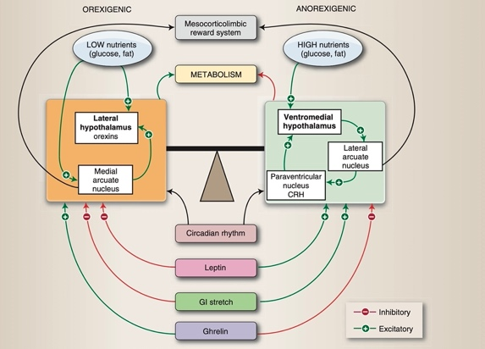

Figure 2. Gut-Brain Axis(Krebs, Claudia ; Weinberg, Joanne ; Akesson, 2019)

Insomnia is a form of sleep disorder defined as a subjective perception of difficulty starting sleep, lack of duration, impaired consolidation or quality of sleep despite being given enough time. Currently insomnia is reported as the most common sleep-related disorder and is the second most frequent complaint in adult patients after pain in primary healthcare (30-50%). Insomnia affects the quality of life of the sufferer and can lead to other conditions such as depression, anxiety and heart disease. The use of medical management is associated with various risks such as drug abuse, drug dependence, work accidents and cognitive impairment. The many side effects and high economic burden of medical administration cause concern for users.(Islamiyah, 2018; Kementrian Kesehatan Republik Indonesia/Kemenkes RI, 2018; Siclari, 2023)

Non-pharmacological management in treating insomnia is still not widely used and its efficacy has not been widely researched. One approach that has potential is Intermittent Fasting (IF) or also known as Time Restricted Feeding (TRF) where a person is given a window to eat in a few hours every day and outside that time window there should be no consumption of substances that have a calorie content. In addition to being easy to recommend to the general population due to its easy and inexpensive intervention methods, this dietary modification has the potential to improve sleep quality through gut-brain Axis. A prolonged state of ketosis from IF will increase leptin levels and lower ghrelin levels which has a negative effect on metabolism and inflammatory processes of the body, in general this is good in supporting the sleep process. This diet modification will also naturally allow enough time between the last meal and sleep that will help restore the circadian rhythm and normal sleep cycle (figure 3). (Haupt et al., 2021; Hosseini et al., 2023).

Figure 3. Effects of IF on body metabolism(Haupt et al., 2021)

**METHOD**

A systematic search of English and Indonesian electronic databases (PubMed, Google Scholar, Willey Online, Research Gate, Science Direct and Neurona) was conducted in November 2024. The search was used to identify studies that examined the relationship between IF and sleep quality. The keywords used are as follows: ("Intermittent Fasting" OR "Intermittent Diet" OR "Limited Time Diet" OR "Intermittent Fasting" OR "Time Restricted Eating" OR "Time Restricted Feeding" OR "Time Restricted Diet") and ("Insomnia" OR "Sleep Disturbance" OR "Sleep disturbance"). Further research will be identified if it is relevant to the research objectives. The search and journal selection was carried out by three researchers independently.

The following are the inclusion criteria for assessing the journal: (1) research design *Randomized Controlled Trial*, (2) Participants diagnosed with insomnia, (3) adult population > 16 years, (4) Have data on the relationship between IF and sleep quality in the form of *Pittsburgh Sleep Quality Index* (PSQI), *Insomnia Severity Index* (CONTENT) and *Total Sleep Duration.* On the other hand, journals with the following characteristics will be excluded from the research: (1) Unpublished research), (2) Articles *Reviews*, (3) Previous meta-analysis, (4) Research outside Indonesian and English, (5) Intervention with *Ramadhan Fasting* / Ramadan fasting.

Data extraction using electronic tables is used as a guide to assess existing studies. The data taken were as follows: (1) Name of researcher, location and year of publication, (2) Age range and number of population, (3) Insomnia diagnosis method, (4) Intervention: feeding window and duration of intervention, (5) output parameters) and (6) output results.

**RESULTS AND DISCUSSION**

***Selection and Characteristics of Research Studies***

The journal search process uses the PRISMA flow as shown in figure 4. Of the 594 potential articles, 152 and 433 were excluded based on title and abstract evaluation. Leaving 9 journals that after further reading 2 were excluded for using interventions *Ramadhan Fasting* and 2 there is no clear method of establishing an insomnia diagnosis. In the end, 5 journals were selected, all of which were conducted in the United States, the age range of the research sample was 18-65 years. The intervention was carried out in the form of IF with a variation of the eating window of 6 – 8 hours, the time of breaking the fast varied from 08.00 to 13.00, the duration of the intervention was between 3 to 6 months. Parameters of insomnia diagnosis and external obtained.

***Bias Risk Assessment***

The risk of bias assessment in this study was carried out using RoB2 (Risk of Bias 2.0) which is specifically designed to evaluate the risk of bias in research-based studies *randomized controlled trial.* This tool evaluates risk bias in five main domains, namely (1) the randomization process, (2) deviation from the planned intervention, (3) missing outcome data, (4) outcome measurement and (5) selection of reported outcomes. Overall, most journals are low-risk, with the highest risk of bias in outcome measurement and missing data. This is contributed by subjective data measurement methods accompanied by a lack of monitoring, small sample counts and large number of subjects missing from the study (figure 5).

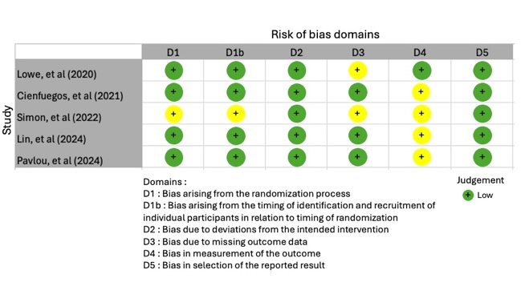

Figure 4. Risk Bias evaluation by RoB2 Tools

**Meta Analysis & Subgroup Analysis**

Meta Analysis of IF against *total sleep time* obtained WMD 2.1 (95% CI: -0.05, 0.81), *p value* < 0.001 and the value of I2 = 98% (figure 6). Analysis of the 8-hour dining window subgroup (Simon, et al and Lowe, et al) obtained WMD results of 3.5 (2.89, 4.11), *p value* < 0.001 and the value of I2 = 89% (figure 7). This shows a positive effect but is not accompanied by good homogeneity, subgroup analysis shows an improvement from a positive effect but is not accompanied by an improvement in homogeneity.

The meta-analysis of IF on PSQI was obtained with WMD results of -0.06 (95% CI: -0.41, 0.75), *p value* < 0.001 and I2 value = 98% (figure 8). Analysis of the subgroup over the duration of the 6-month intervention (Lin, et al and Pavlou, et al) found a significant change in WMD of 0.61 (95% CI: 0.23, 0.98), *p value* < 0.21 and I2 value = 38% (figure 9). These results showed a negative effect with high heterogeneity with significant changes in the subgroup analysis. In the subgroup for the duration of the 6-month intervention, the effect was positive and the data were heterogeneous.

The meta-analysis of IF to ISI obtained WMD results of 0.58 (95% CI: 0.17, 1.00), *p-value* < 0.001 and I2 value = 98% (figure 10). Analysis of the 6-month intervention subgroup (Lin, et al and Pavlou, et al) obtained a WMD of 0.96 (95% CI: 0.54, 1.38), *a p value* of < 0.001 and a value of I2 = 97% (figure 11). These results showed positive effects with heterogeneous data, the subgroup analysis did not provide a significant improvement in either the effect or heterogeneity.

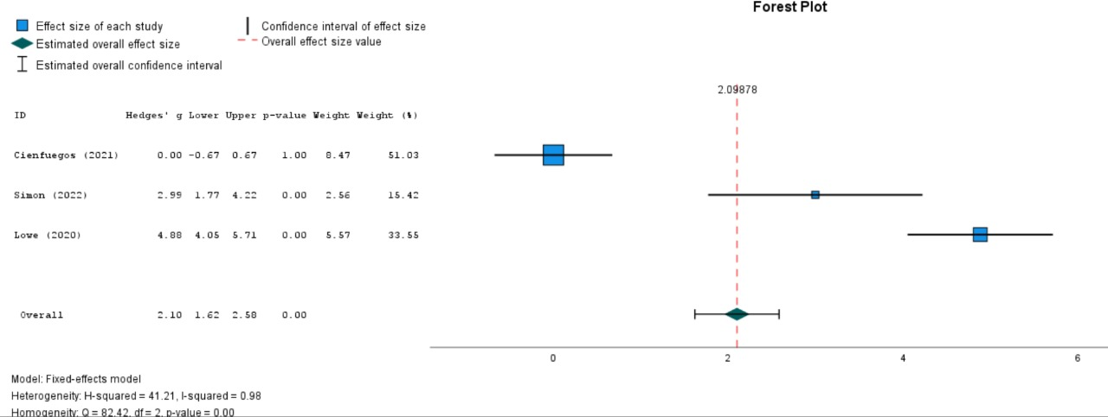

Figure 5. Forest Plot IF on *total sleep time*

Figure 6. Forest Plot IF to total *sleep time* (8-hour meal window subgroup)

Figure 7. Forest Plot IF against *PSQI*

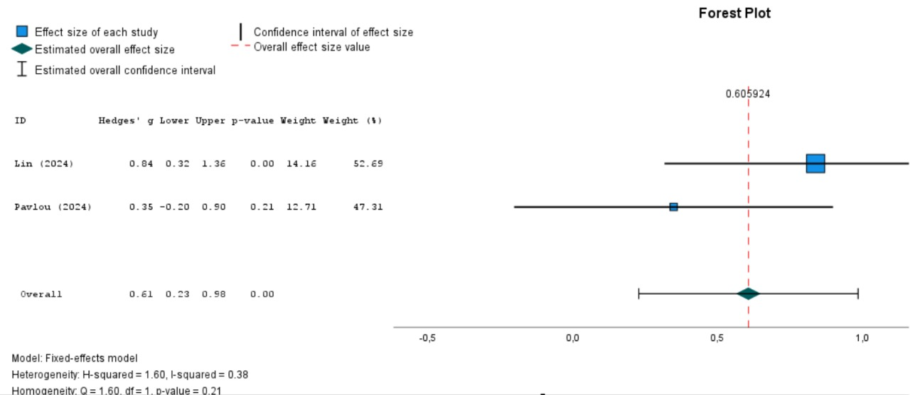

Figure 8. Forest Plot IF against *PSQI* (subgroup 6 months)

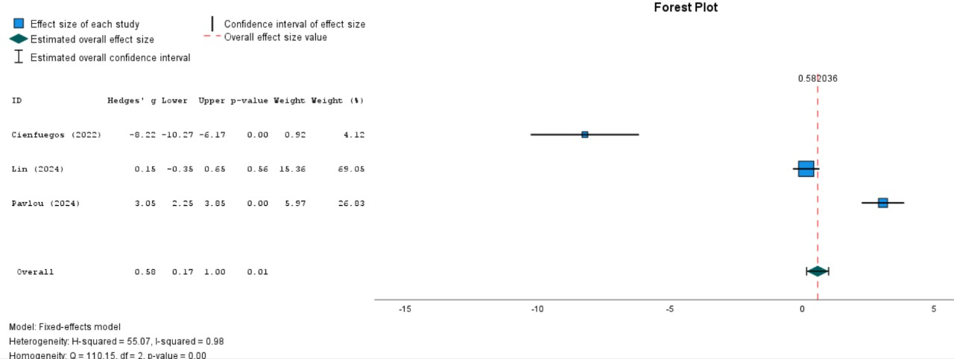

Figure 9. Forest Plot IF against CONTENTS

Figure 10. Forest Plot IF against ISI (6-month intervention subgroup)

Insomnia is the most common sleep disorder and is often found in medical practice. Insomnia can present with a variety of complaints and etiologies both physical and psychological. One of the things that is disturbed in insomnia is the circadian rhythm which plays a role in regulating the sleep and wake cycle. Melatonin produced by the suprachiasma nucleus is the main hormone for sleep initiation and melatonin production is influenced by various factors such as external activities as well as digestive hormones. Leptin and ghrelin are digestive hormones that play a role in *gut-brain axis* Where leptin secretion not only plays a role in reducing stomach acid production but also works on the ventral hypothalamus in reducing metabolism and inflammation and increasing melatonin production. *Intermittent Fasting* is a form of diet modification by providing a window of eating every day and beyond that calorie fasting is carried out. The goal to be achieved is leptin levels and lowering ghrelin levels through the caloric fasting phase outside the predetermined eating window. Fung, et al in their study stated that this can be achieved after IF of more than 3 days, but in the early phase the opposite effect occurs (decrease in leptin and ghrelin). Another benefit that can be achieved is the gap between the last meal and bedtime which can help the body restore its irregular circadian rhythm. Blum, et al state that the eating window affects the outcome of sleep quality, with an earlier eating window (8 a.m. – 4 p.m.) providing a slightly better improvement in sleep quality compared to a daytime eating window (12 p.m. – 8 p.m.). (Blum et al., 2023; Haupt et al., 2021; Hosseini et al., 2023; Islamiyah, 2018; Patterson & Sears, 2017; Xie et al., 2022),(BaHammam & Pirzada, 2023).

In the meta-analysis of the influence of IF on *total sleep time* Positive effects were obtained with heterogeneous data, and subgroup analysis also did not provide significant improvements. In addition to the feeding window, the duration of the intervention in IF also had an effect on the outcome. Hutchison, et al (2019) stated that IF with a 9-hour eating window for 1 week did not provide an improvement in sleep duration, Bealieu, et al (2021) stated that IF for 3 months provided an improvement in sleep duration. The studies included in this meta-analysis took a duration of 12 weeks, which is in line with previous research that stated that there was already a positive impact of IF on total sleep time. The heterogeneity in this study was due to randomization bias, differences in fasting length and the number of dropout which is high in some studies. Subgroup analysis showed a more positive effect which is in line with the research so far using the duration of the feeding window > 8 jam.(Beaulieu et al., 2020; Blum et al., 2023; Vujović et al., 2023).

Meta-analysis The effect of IF on PSQI was initially obtained with heterogeneous data, while in the subgroup analysis, positive effects were obtained with homogeneous data. This shows that differences in intervention methods and differences in sample populations affect data heterogeneity. Xiao, et al (2021) demonstrated that the IF for 1 month gave a worse score to the PSQI while Wilkinson, et al (2020) and Gabe, et al (2018) showed that the IF for 10 and 12 weeks showed no improvement from the PSQI score. This can be linked to the theory from Fung, et al that improvements in circadian rhythms cannot occur in a short period of time. The optimal IF duration for improvement from the current PSQI score is not yet known.(BaHammam & Pirzada, 2023; Gabel et al., 2019; Teong et al., 2021; Wilkinson et al., 2020).

In the Meta Analysis of the influence of IF on ISI, positive effects and heterogeneous data were obtained, subgroup analysts made improvements to positive effects but still obtained heterogeneous data. Mara, et al (2020) and Gabe, et al (2018) showed that practicing IF for 8 hours daily for 8-12 weeks did not provide a significant improvement in ISI scores. This is in accordance with the findings of the analysis of the 6-month intervention subgroup which had a more positive effect. Randomization bias, differences in fasting, and differences in samples play a role in data heterogeneity (Kalam et al., 2021; McStay et al., 2021; Teong et al., 2021)

**CONCLUSION**

Intermittent fasting, a dietary modification, has been shown to improve sleep quality, as measured by total sleep time, the Pittsburgh Sleep Quality Index (PSQI), and the Insomnia Severity Index (ISI). Notably, a positive effect on PSQI was observed in studies with a 6-month intervention, while shorter interventions of more than 3 months yielded negative results. However, heterogeneity in the meta-analysis and subgroup analyses—stemming from factors such as randomization methods, variations in interventions, differences in sample sizes, and participant dropouts—introduced potential bias. Future research should focus on larger sample sizes, an earlier fasting window, and a consistent 6-month intervention period to better clarify the benefits of intermittent fasting on sleep quality.

**REFERENCES**

BaHammam, A. S., & Pirzada, A. (2023). Timing Matters: The Interplay between Early Mealtime, Circadian Rhythms, Gene Expression, Circadian Hormones, and Metabolism—A Narrative Review. *Clocks and Sleep*, *5*(3), 507–535. https://doi.org/10.3390/clockssleep5030034

Beaulieu, K., Casanova, N., Oustric, P., Turicchi, J., Gibbons, C., Hopkins, M., Varady, K., Blundell, J., & Finlayson, G. (2020). Matched Weight Loss Through Intermittent or Continuous Energy Restriction Does Not Lead to Compensatory Increases in Appetite and Eating Behavior in a Randomized Controlled Trial in Women with Overweight and Obesity. *Journal of Nutrition*, *150*(3), 623–633. https://doi.org/10.1093/jn/nxz296

Blum, D. J., Hernandez, B., & Zeitzer, J. M. (2023). Early time-restricted eating advances sleep in late sleepers: A pilot randomized controlled trial. *Journal of Clinical Sleep Medicine*, *19*(12), 2097–2106. https://doi.org/10.5664/jcsm.10754

Gabel, K., Hoddy, K. K., Burgess, H. J., & Varady, K. A. (2019). Effect of 8-h time-restricted feeding on sleep quality and duration in adults with obesity. *Applied Physiology, Nutrition and Metabolism*, *44*(8), 903–906. https://doi.org/10.1139/apnm-2019-0032

Haupt, S., Eckstein, M. L., Wolf, A., Zimmer, R. T., Wachsmuth, N. B., & Moser, O. (2021). Eat, train, sleep—retreat? Hormonal interactions of intermittent fasting, exercise and circadian rhythm. *Biomolecules*, *11*(4), 1–19. https://doi.org/10.3390/biom11040516

Hosseini, E., Ammar, A., Josephson, J. K., Gibson, D. L., Askari, G., Bragazzi, N. L., Trabelsi, K., Schöllhorn, W. I., & Mokhtari, Z. (2023). Fasting diets: what are the impacts on eating behaviors, sleep, mood, and well-being? *Frontiers in Nutrition*, *10*(January). https://doi.org/10.3389/fnut.2023.1256101

Islamiyah, W. (2018). Panduan Tatalaksana Gangguan Tidur. In W. R. Islamiyah (Ed.), *Buku Panduan* (2nd ed, Vol. 1). Sagung Seto.

Kalam, F., Gabel, K., Cienfuegos, S., Ezpeleta, M., Wiseman, E., & Varady, K. A. (2021). Alternate day fasting combined with a low carbohydrate diet: Effect on sleep quality, duration, insomnia severity and risk of obstructive sleep apnea in adults with obesity. *Nutrients*, *13*(1), 1–10. https://doi.org/10.3390/nu13010211

Kementrian Kesehatan Republik Indonesia/Kemenkes RI. (2018). Laporan_Nasional_RKD2018_FINAL.pdf. In *Badan Penelitian dan Pengembangan Kesehatan* (p. 674).

Krebs, Claudia ; Weinberg, Joanne ; Akesson, E. (2019). Lippincott’s Illustrated Reviews of Neuroscience. In R. Harvey (Ed.), *Sustainability (Switzerland)* (1st ed., Vol. 11, Issue 1). Wolters Kluwer.

McStay, M., Gabel, K., Cienfuegos, S., Ezpeleta, M., Lin, S., & Varady, K. A. (2021). Intermittent fasting and sleep: A review of human trials. *Nutrients*, *13*(10). https://doi.org/10.3390/nu13103489

Patterson, R. E., & Sears, D. D. (2017). Metabolic Effects of Intermittent Fasting. *Annual Review of Nutrition*, *37*, 371–393. https://doi.org/10.1146/annurev-nutr-071816-064634

Siclari, F. (2023). Neurobiology of dreams. In *Encyclopedia of Sleep and Circadian Rhythms: Volume 1-6, Second Edition*. https://doi.org/10.1016/B978-0-12-822963-7.00119-5

Teong, X. T., Hutchison, A. T., Liu, B., Wittert, G. A., Lange, K., Banks, S., & Heilbronn, L. K. (2021). Eight weeks of intermittent fasting versus calorie restriction does not alter eating behaviors, mood, sleep quality, quality of life and cognitive performance in women with overweight. *Nutrition Research*, *92*, 32–39. https://doi.org/10.1016/j.nutres.2021.06.006

Vujović, N., Piron, M. J., Qian, J., Chellappa, S. L., Barr, D., Heng, S. W., Kerlin, K., Srivastav, S., Wang, W., Shoji, B., Garaulet, M., Brady, M. J., & Scheer, F. A. J. L. (2023). *HHS Public Access overweight and obesity*. *34*(10), 1486–1498. https://doi.org/10.1016/j.cmet.2022.09.007.Late

Wilkinson, M. J., Manoogian, E. N. C., Zadourian, A., Lo, H., Fakhouri, S., Shoghi, A., Wang, X., Fleischer, J. G., Navlakha, S., Panda, S., & Taub, P. R. (2020). Ten-Hour Time-Restricted Eating Reduces Weight, Blood Pressure, and Atherogenic Lipids in Patients with Metabolic Syndrome. *Cell Metabolism*, *31*(1), 92-104.e5. https://doi.org/10.1016/j.cmet.2019.11.004

Xie, Z., Sun, Y., Ye, Y., Hu, D., Zhang, H., He, Z., Zhao, H., Yang, H., & Mao, Y. (2022). Randomized controlled trial for time-restricted eating in healthy volunteers without obesity. *Nature Communications*, *13*(1), 1–10. https://doi.org/10.1038/s41467-022-28662-5